1st National Conference on

**N**

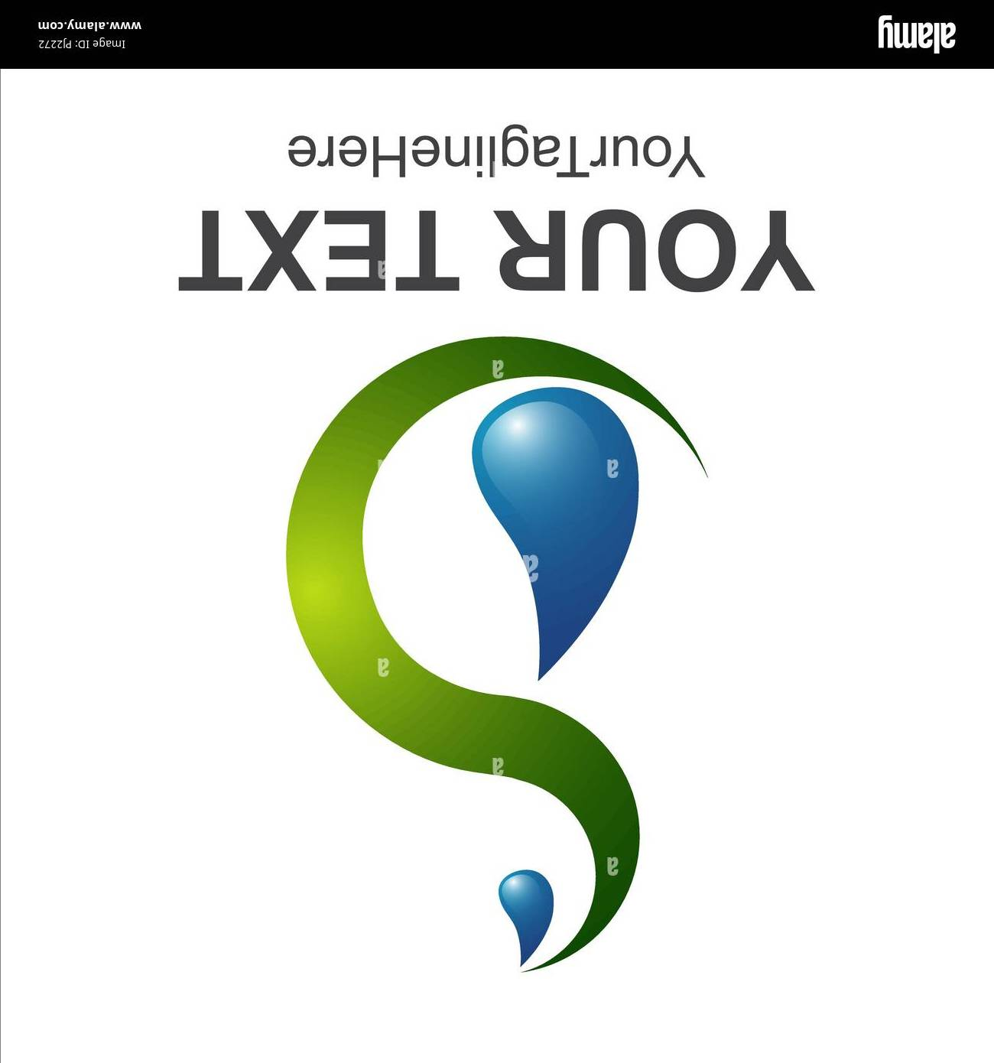

**2**



**24**



***1***

**WSE-S**

Water, Soil and Environment Sustainability

NCWSE-S’2024

4th November 2024***, Mascara-Algeria***

**Registration form for Conference participants**

**Please complete this form** **and return by E-mail latest until:** 15 July 2024

[ncwse-s2024@univ-mascara.dz](mailto:ncwse-s2024@univ-mascara.dz)

**Registration**

|  |  |  |  |  |  |  |
| --- | --- | --- | --- | --- | --- | --- |
|  | **Mr.** | **Ms.** | **PhD student** | **Dr.** | **Prof.** | **Other** |
|  |  |  |  |  |  |  |
| **Full Familiy name** |  | | | | | |
| **Full First name** |  | | | | | |
| **Company/University/Institution** |  | | | | | |
| **Adress** |  | | | | | |
| **Phone** |  | | | | | |
| **E-mail** |  | | | | | |

**Type of presentation and themes**

|  |  |
| --- | --- |
| **Oral presentation** | **Theme 1 Theme 2** |
| **Poster presentation** | **Theme 3 Theme 4** |

**Abstract submission (Abstract is a part of registration form)**

|  |
| --- |
| **TITLE OF PAPER**  FULL FAMILY NAME Full first name1, FULL FAMILY NAME Full first name1* and FULL FAMILY NAME Full first name2  *1Affiliation*  *2Affiliation*  *author@.................(*Corresponding author’s email)  **ABSTRACT**  An abstract is a single paragraph, without subheadings, indentation or references. It should be an explicit summary of your presentation that states the problem, the objectives, the methods used, and the major results and conclusions. It should be single-spaced in 12-point Times New Roman. Do not include bullets or lists in the abstract. Use only the SI units. Chemical formulae should be written in standard. The first part of your abstract should state the purpose of your study. Your abstract should also describe the research methods. Next, your abstract should indicate the results or outcomes of the work you have done so far. Finally, your abstract should close with a statement of the project’s implications and contributions to its field. The content of the abstract will be the basis for acceptance of paper presentation at the national conference. The abstracts will be peer-reviewed and authors will be informed about acceptance for presentation via email. The abstract should be submitted in the format of MS Word (.doc or .docx) document and should not exceed 500 words on any of the aforesaid themes. Keywords should be given leaving one-line space below this text.  **Keywords**: single, paragraph, summarizes, words indentation (maximum 6 words). |

Location, date, signature: